Kelly Morgan

Usability Study

1. Imaginary Users
   1. Paul is a 18-year-old freshman at UMW. He didn’t take any finance classes in high school, but he thinks taking some basic finance classes would be helpful. He uses different web applications frequently, and is comfortable clicking around on a website to explore features. He enjoys video games in his free time and is familiar with common game elements, such as non-playable characters (NPCs).
   2. Tom has decided to go back to school to get a second degree. He’s in his mid-50s, and uses a computer at home. He’s comfortable with using a few applications, like Word, a browser, and checking his email, but whenever he uses a new application he likes to find directions first. Having owned a home for years and budgeted for various needs, he’s familiar with basic financial principles but would like to learn more.
   3. Mary is a 20-year-old junior at UMW. She’s an English major, but realizes she has not yet fulfilled all her Gen Ed requirements. She decides to take a finance class, both for the knowledge and the credits. She’s comfortable using web applications, but does not have a lot of experience with video games. She also participates in several clubs, so she sometimes decides to skip smaller homework assignments in favor of attending a club meeting, but would do the homework if it didn’t take so long.
2. User Model
   1. The application is a Finance Role Playing Game, or Finance RPG. Users can play as a character to learn financial principles and progress through the worlds of finance week by week. Students will be able to interact at some level with the worlds/levels in a Campaign mode. They can also do a faster, multiple-choice quiz style Lightning Round to reinforce definitions and conceptual questions. By playing along with the concepts being learned in class, users will be able to use the game to study, complete assignments, and have fun.
   2. Feedback: How will they interact with it? (the following are quotes)
      1. Primarily in a quiz-based way, mainly clicking
      2. I guess with the quizzes?
      3. In a browser window
      4. By using quizzes

What should they be able to do?

1. Learn knowledge and basic principles of finance, have fun, be an accountant or “finance warrior”
2. Follow with the course content
3. Make choices, sort of like you would in Dungeons and Dragons
4. It should have enough stuff that it works for everything assignments would cover

What should they not be able to do? What's important to them?

1. Shouldn’t be able to cheat. Engagement, clean interface, well described explanations of answers; potentially why the wrong answers are wrong (be very specific), if you’ve never heard of it before you should now be able to accomplish the question; the explanation should even include a review of relevant principles
2. Jump really far ahead to other levels. Having fun with it, help students want to learn more about finance
3. The same questions over and over. A game that makes sense, it sounds like there’s a lot that goes into it and it’s only fun if you know what you’re doing; I initially thought it was a money management game like Rollercoaster Tycoon or something but I think that’s wrong now
4. Shouldn’t need a lot of knowledge on RPGs. Being able to access the game whenever you need to
   1. User Model
      1. Overall, students want the game to be fun, and have an appealing interface. It is important to make sure the game makes sense with course material, as is allowing for the Lightning Round quizzes to actually review week by week. The game should ensure that no background knowledge of games is needed, and that questions are different enough to provide an adequate review.
5. Prototype Images (“Play a level 2 Lightning Round”)

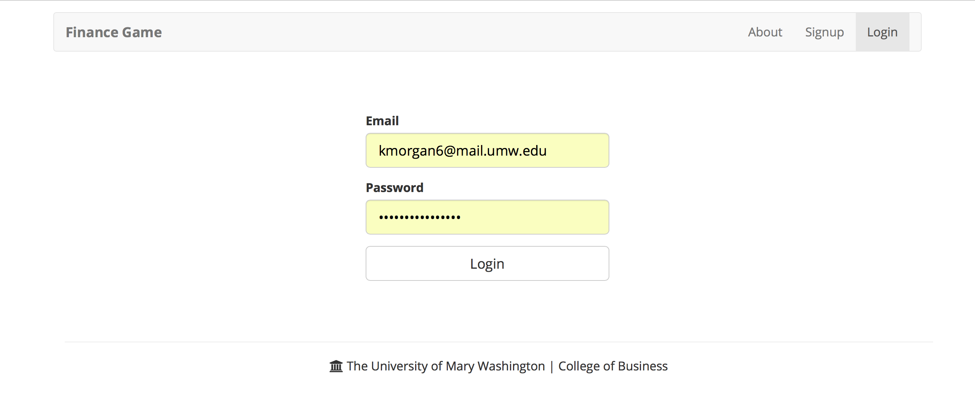

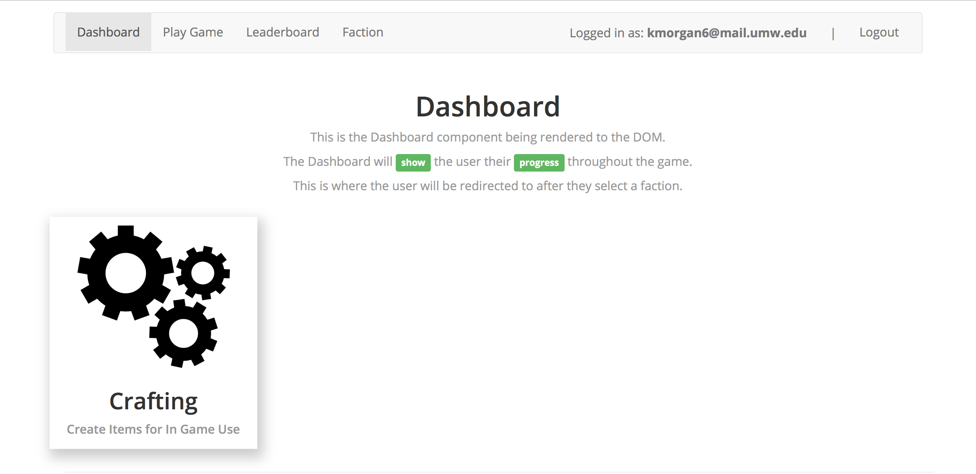

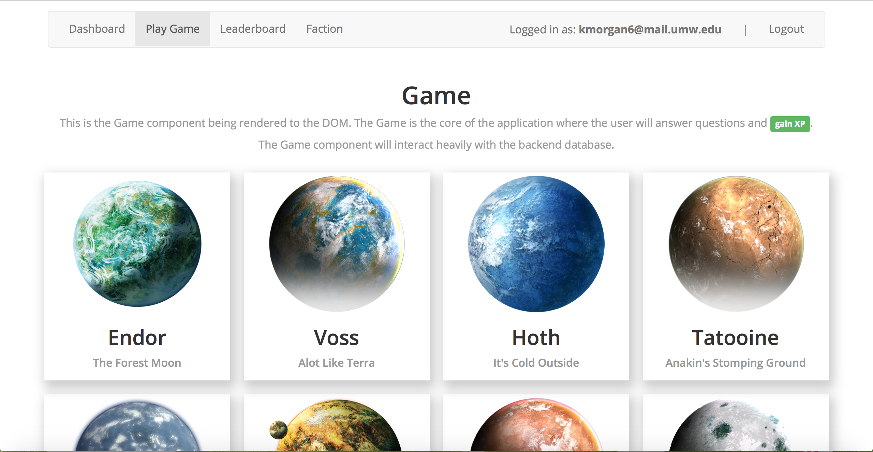



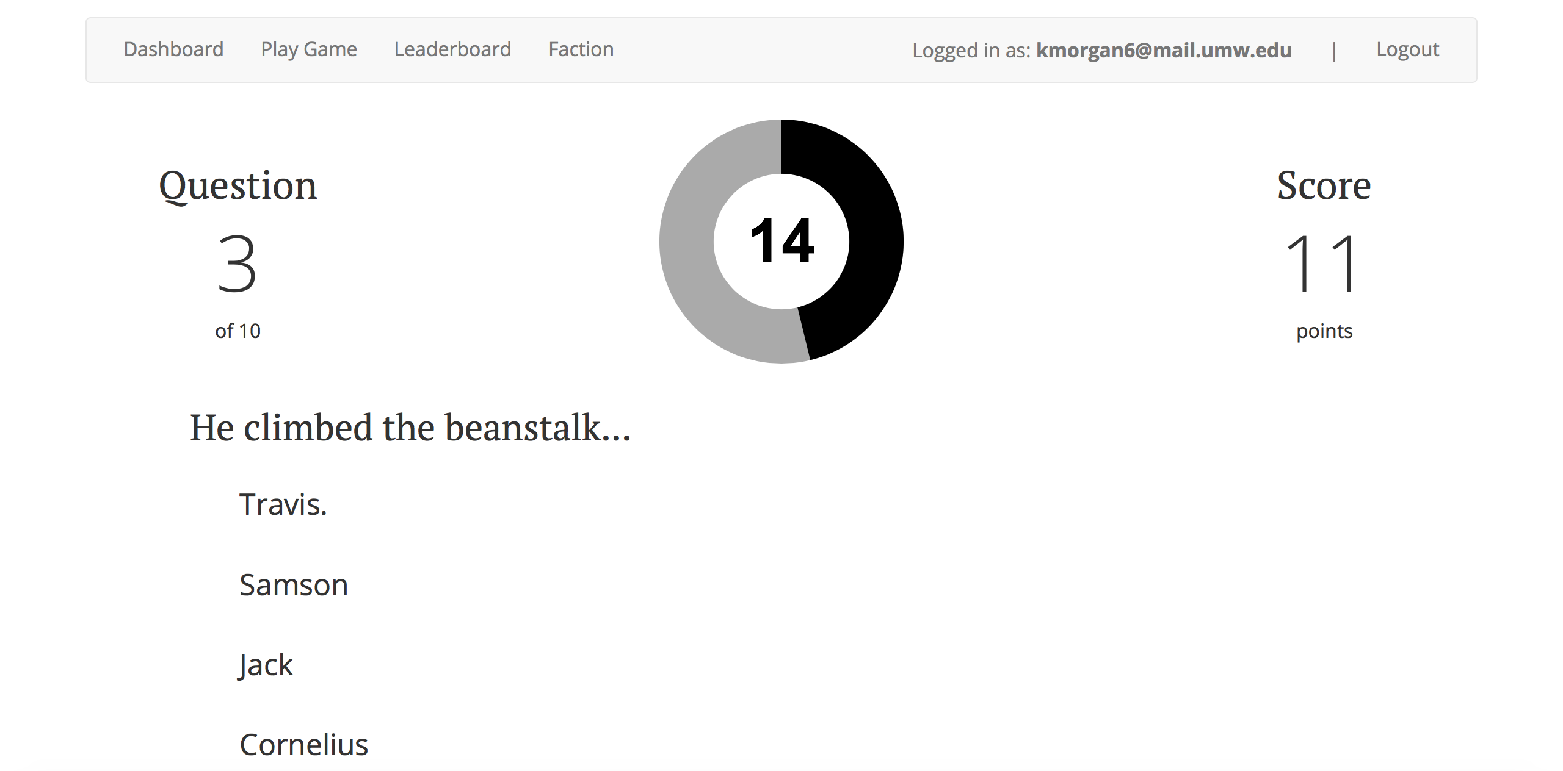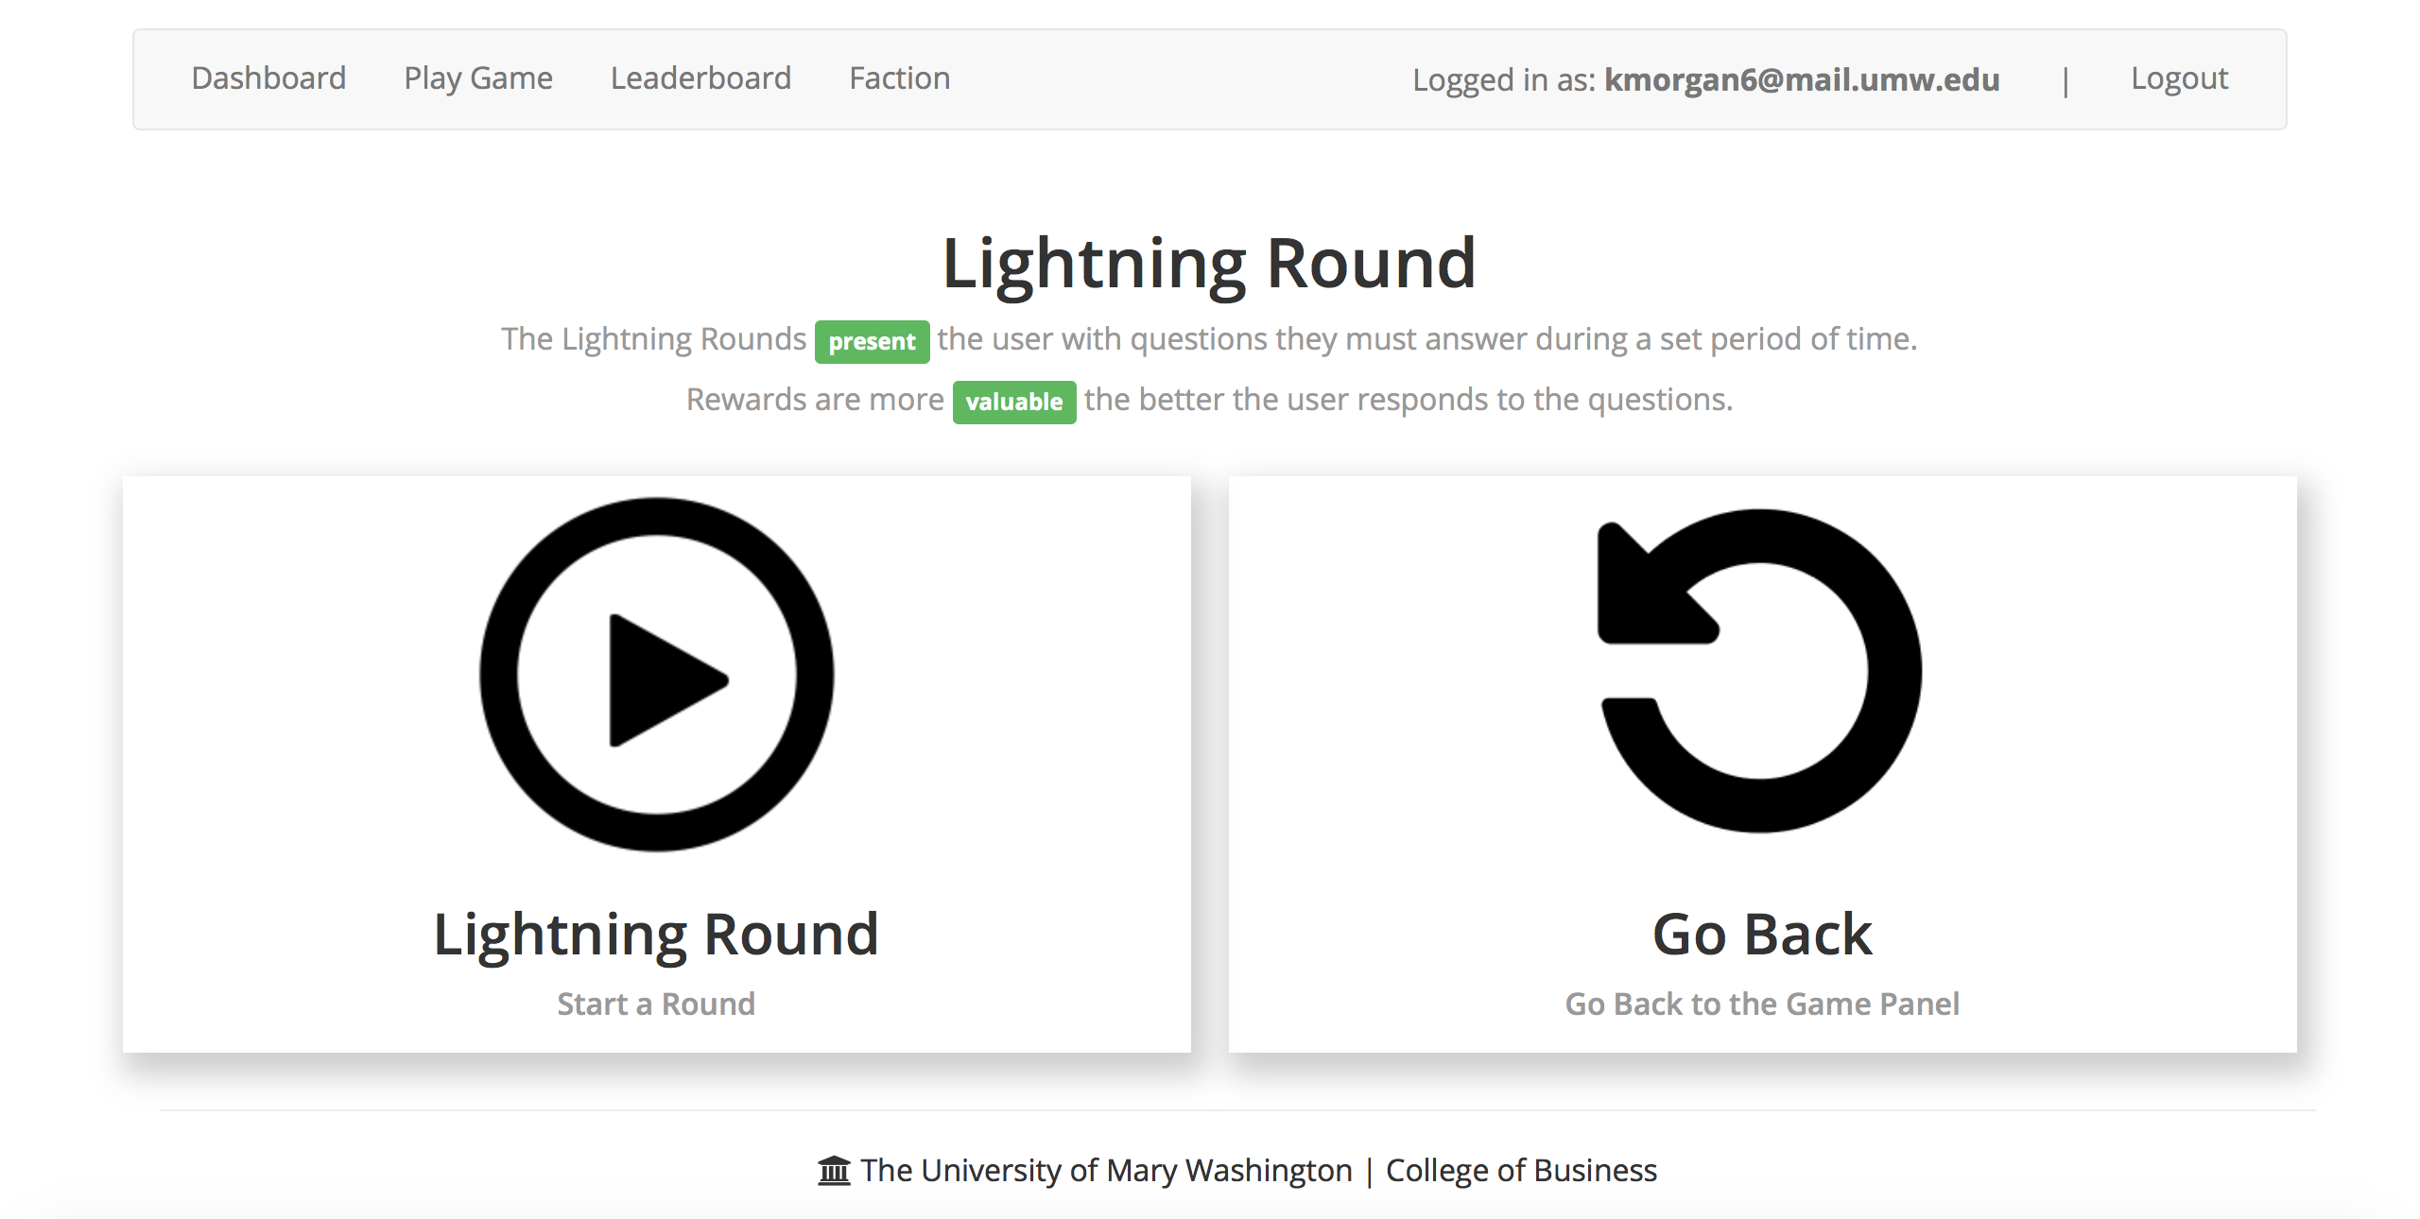

1. Focus Group Feedback
   1. Comments
      1. Everything is pretty straightforward, except levels. I log in, go to the game page, but first I thought Death Star II was level two. It wasn’t, but there’s nothing that makes that clear. Playing the Lightning Round was fine, though.
      2. I don’t think it’s too hard to go through the game. It’s just a couple steps to play. The email login was confusing, though, since I tried to use Gmail and I didn’t know why it didn’t work.
      3. Yeah, it all made sense. I usually use my school email so that’s what I tried and it worked. Oh, yeah, the levels were sort of confusing.
      4. It logged into the Faction page first, which was weird. I know we were supposed to play the game, but I had to find the game tab first. After that it was great!
   2. Reflection
      1. Yes, everyone was comfortable with the quiz-style implementation, and that helped ensure that everyone essentially knew how to do the Lightning Round already. The user that initially thought it was a money management game was a bit confused, but it made sense to them later.
2. Changes
   1. The main change we need to make is more clearly identifying levels. Instead of assuming that users will know Endor is level one, Voss is level two, etc., we need to specifically state which world corresponds to which level. We also need to make sure users know that they have to use a UMW email, not Gmail or any other email. Essentially, making sure that we explain the type of input the game requires will go a long way in making sure it makes sense for our users.